SDSU Senate Minutes
February 2, 2021
2:00 to 4:30 pm

Preciado, Wheeler, Lach, Juan, Wills, Nedjat-Haiem, Smigel, Abusham, Bliss, May-Newman, Cappello, Ahsan, Espinosa, Love, Lindemann, Atkins, Schulze, Bernerth, Brandon, Adams, Canary, Record, Greiner, Vaughn, Sabol, Interlando, Zona, Alkebulan, Csomay, Mahar, Brown, Ryan, McDaniels-Davidson, Quick, Attiq, MacKenzie, Corlett, Marx, Kressler, Blomgren, O'Brien, Putman, Sharma, Samraj, Rhodes, Harrison, Barbone, Urzua Beltran, Atterton, Hopkins, Weston, Abarbanell, Sasidharan, Gates, Krivogorsky, Bohonak, Orosz, Rehfuss, Gill, Gontz, Werry, Gibbons, Wood, Penrose Jr., Laurie, Abdel-Nour, Hentschel, Purse, Kraemer, Duesbery, Morsi, Holt, Madanat, Wong Nickerson, Lenoue, Sepulveda II, Tang, Stoskopf, Ponce, Brandon, Abdel-Samad, Miles (formerly Poor), Schellenberg, Brown, Love, Crawford, Ozturk, Molina, Richeson, Roberts, Swanson, Abel Mills, Qin, Ornatowski
Rothenberger, Ochoa

Guests- Sheehan, O'Sullivan, De La Torre, Skiles, Dooley
- Call to Order, Land Acknowledgement, and Principles of Shared Governance:
Land Acknowledgement: The Senate Chair reads Kumeyaay land acknowledgement.
We stand upon a land that carries the footsteps of millennia of Kumeyaay people. They are a people whose traditional lifeways inter
twine with a worldview of earth and sky in a community of living beings. This land is part of a relationship that has nourished, healed, protected and embraced the Kumeyaay people to the present day. It is part of a world view founded in the harmony of the cycles of the sky and balance in the forces of life. For the Kumeyaay, red and black represent the balance of those forces that provide for harmony within our bodies as well as the world around us.

As students, faculty, staff and alumni of San Diego State University we acknowledge this legacy from the Kumeyaay. We promote this balance in life as we pursue our goals of knowledge and understanding. We find inspiration in the Kumeyaay spirit to open our minds and hearts. It is the legacy of the red and black. It is the land of the Kumeyaay.

Eyay e’Hunn My heart is good.

Michael Miskwish – Kumeyaay

Principles of Shared Governance: The Senate Chair reads the principles statement.
Trust is recognized as a fundamental ingredient that is essential for effective shared governance. Without trust, the practices of partnership, inclusion, open communication, ownership, and accountability are likely to break down. SDSU community members have identified three key principles for shared governance at SDSU that all rely on the fundamental ingredient of TRUST: Respect, Communication, Responsibility.
- Approval of Agenda (Preciado)
Preciado/Greiner made a motion to adopt agenda with 5.5 item withdrawn. The agenda is approved without objection.
Item 5.5 Mirrored Programs are withdrawn to be presented at a town hall prior to the University Senate meeting of March 2, 2021. Senator Sepulveda requested an item to be added to the agenda. Senator Sepulveda requested a waiver of the four-day rule to add the agenda item. Senator Adams made a parliamentary inquiry regarding Senator Sepulveda’s request. Chair Weston and Parliamentarian Eaddy offered their interpretation of the senate policy regarding amending the agenda.
Senator Holt asked for a parliamentary inquiry regarding amending the agenda in accordance with Senate rules 8.4. and 8.8 Senator.
Senators Vaughn/Sepulveda moved to waive the 4-day rule to add an item to the agenda. Motion carried with a vote for 40 to 3.
Another vote was taken to amend the agenda to include a proposal to update the credit no-credit policy for Spring 21 and Summer 21 semesters. An image of language adopted is included below as a report from Academic Policy and Planning committee.
Senators provided statements in support of extending these policies during the period of the pandemic. A friendly amendment was made by Vice Chair Butler-Byrd to extend the policy indefinitely.
Data was requested on the use of the credit/ no credit and other practices have been used by the students during COVID-19 impacted semesters. The provost offered to look into the overall impact of COVID-19 on student data after the fall registration project is completed.
Chair Hopkins shared that AP and P did review data within the committee:
4.06 % Fall 2019 of grades were credit/no credit (regular semester)
5.81 % Spring 2020 of grades were credit/no credit (COVID-19 Impacted Semester)
7.24 % Fall 2020 of grades were credit/no credit (COVID-19 Impacted Semester)
(A screenshot of the item and partial minutes are included below).
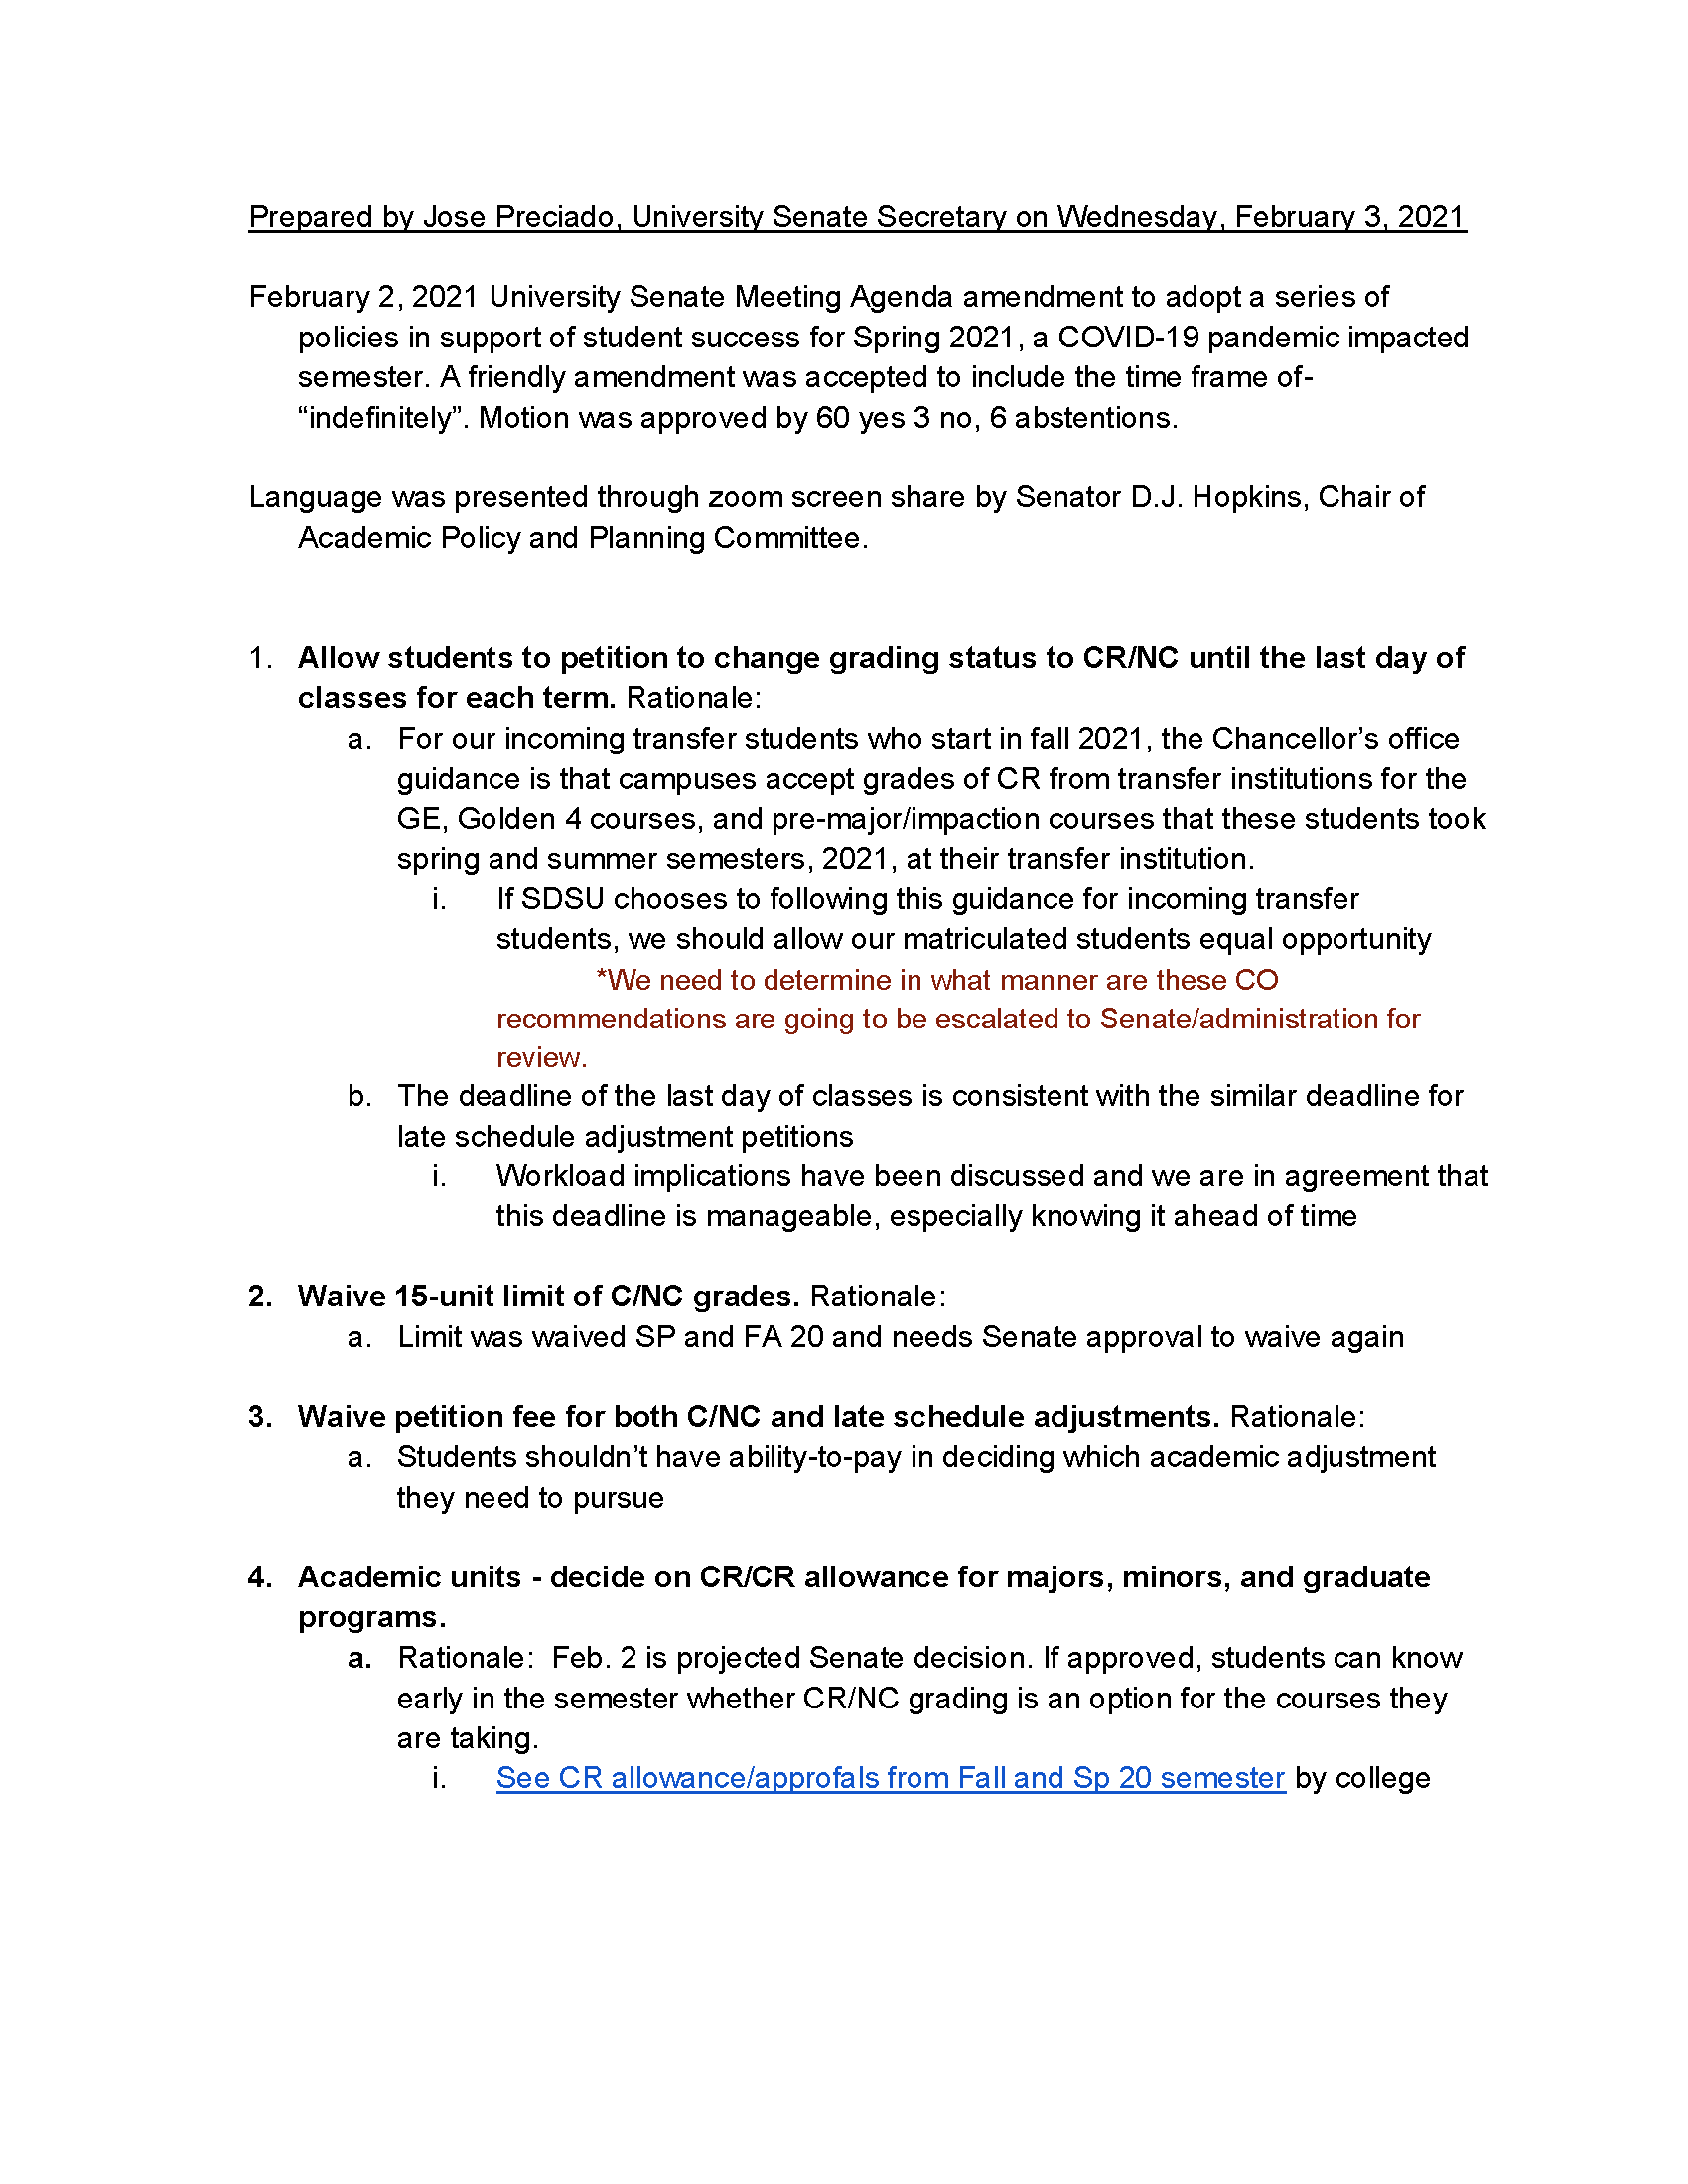

Officers Report
  - Referrals Chart (Butler-Byrd)…………………………………………………………4
Vice Chair Butler-Byrd offered noted 43 items are on the tracking document.

  - Senate Budget Update (Fuller)
Treasurer Fuller had no report.
  - Senate Minutes November 10th and December 1st Minutes (Preciado)
Preciado/Greiner moved approval of November 10, 2020 and December 1, 2020 with an amendment to the attendance roster to include Senator Gibbons for the December 1 meeting.
- Academic Affairs Report
  - President comments (de la Torre)
COVID-19 vaccinations will be provided at SDSU beginning this week. 300 doses will be made available to the SDSU community using county phases/tiers to determine eligibility participation. All campus employees can continue to go to their providers and the County of San Diego for vaccinations- SDSU is just another option. As the supply of vaccines grows, more SDSU employees will be invited to participate. Senator Quick inquired about Spring 2021 instructors who are teaching in-person classes. Senator Greiner expressed appreciation to President De la Torre for her efforts. President acknowledged members of her senior staff who made this possible (Madanat, Skiles, Dooley). President expressed appreciation to Senator Greiner (Director of School of Nursing). Secretary Preciado asked about Tier 1B that includes education staff. Are university personnel included in the education staff noted in the Tier 1B? Student Health Services Director Skiles indicated that efforts are underway to clarify. Director Skiles confirmed that the Student Health Services in Calpulli is the location of the vaccination center. President De La Torre explained that the vaccination cannot be required of anyone because it is under emergency approval. Surveillance testing plan continues to be followed and is a component of the “non-pharmaceutical” campus tools to support the health and safety of SDSU personnel and students.
President De la Torre shared that she is engaged in working with elected officials to restore recurring funding to the CSU and to SDSU. In addition, she is seeking to recover the disproportionate cuts that SDSU accrued in support of System. This is in addition to the recently announced Governor’s Budget that also should recognize the disproportionate cut to SDSU and recover funding. The President also shared Chancellor Castro’s statements that furloughs and tuition increases are not planned for as solutions to budget needs Spring 21 or for the following academic year.
  - Provost’s Report (Ochoa)
Search for Vice Provost is underway. The Provost appointed a new faculty from PSFA to replace the elected representative for PSFA, who had to step down because of other commitments. The Provost also discussed the budget prioritization process for the Division of Academic Affairs as part of the annual PBAC process. EEP impacts are under review to determine how to best support Academic Affairs units. The College of Arts and Letters and the College of Sciences will be supported with additional instructional resources to mitigate EEP related cuts for Spring 21. Admission numbers are promising for Fall 2021 for all groups (Freshmen, Transfer, in-state and out-of-state). These numbers are important as they too impact the overall campus budget.
Campus Fall 21 repopulation plans: Most campuses have two plans that reflect the need for contingencies that will emerge depending on the progress made to vaccinate against COVID-19. The associate deans and chairs will be critical contributors to the development of class schedule scenarios for Fall 21. Provost indicated that there will be courses online as the campus does not have capacity based on social distance requirement to return to all in-person courses. Classroom space (number of seats) will be changed based on social distancing scenarios impacting the capacity of the campus to offer in-person courses. Department chairs and associate deans will work with faculty to determine who will or can teach face-to-face in Fall 21. Senators inquired about: 1. innovations to instructional program generated by online courses; 2. whether timeframe for Fall 21 enrollment can be delayed to generate a class schedule that has new information on conditions resulting from vaccinations; 3. optimizing use of instructional space in light of the social distancing- how much information will chairs be provided to make these changes….
The new Ethnic Studies graduation requirement (AB 1460 and CSU Executive Order) will be implemented for Fall 21. Dean Casper and Greg Wilson are leading efforts to work with department chairs to update the catalog to prepare for this new change in graduation requirements. Three departments and one center can offer courses. Diversity courses are different than Ethnic Studies courses. Ethnic Studies curriculum committee will be established within CAL. How will catalog be updated to include area F within GE and the changes to existing courses and the new courses be implemented in terms of shared governance (what is the role of Senate in this process?). AVP Schellenberg provided brief discussion about the integration of the SDSU ethnic studies requirement and the new AB 1460 courses and policy. He indicated that existing courses may be realigned through an editorial process. This will contrast with new courses that will follow a full curricular pathway that exists for new course proposals.
- Senate Actions (Weston)
  - Academic Policy & Planning (Hopkins)
Chair Hopkins introduced the four action items in support of student success. The committee moves approval of items a, b, c, and d.
- Retroactive withdrawal policy revision…………………………………………9
Assistant deans will now approve process without the past practice of consulting with the faculty of record. The faculty of record is not able to know the rationale for the retroactive withdrawal and accepts the assistant dean’s affirmation about the rationale. Item a. is approved with the following vote- 48 yes, 1 no, 7 and
- Term Credit Limits…………………………………………………………….10
Item b is approved without objection.
- Documentation on Admissions Exceptions Policies…………………………..11
Item c is approved without objection.
- Priority Registration for ROTC Students……………………………………...12
Item d is approved without objection.

  - FHAC recommendation for emeritus status. (Anderson/Weston)...............................13
Chair Weston read the names of the retiring faculty listed on page 13. Motion was approved without objection.
  - GE, General Education Program changes (Wilson & Canary)………………………14
Committee moves approval of new courses and modifications. Item is approved without objection.
  - CCE Sustainability Committee appointment (Marx)………………………….……..18
Appointment of Otto Delacruz is made without objection.
  - Mirrored graduate programs at Global Campus (Weston) Time Certain 3:00pm
a. Mirrored grad programs in Master’s of Public Health - Epidemiology (Oren)…..19
b. Mirrored grad programs in Master’s of Social Work (Min)………………….…...26
Item was withdrawn by the Senate Officers and will be part of an upcoming town hall.
4.6. UCC BA in Math added to IVC program offerings (Barbone)………………….…..34
The UCC moved approval the new program of the SDSU Imperial Valley. The program was approved without objection. Past Chair Wheeler expressed appreciation to the University Senate for support of this first program.
- Committee Reports – Motion to receive all other reports was approved without objection.
  - Academic Policy & Planning (Hopkins)………………………………………….….35
- AP&P Federal Title IV Compliance (Hopkins)...................................................37
  - Graduate Council (Gill) Time Certain 3:30pm………………………………….….38
Graduate Council new and revised program and course report was accepted without objection.
  - URAD Report ……………………..……….….……………………………….…….74
  - UCC 2022-2023 General Catalog (Barbone)………………………………….……..83
  - CCE Change in search committee for Vice Provost for Academic Affair (Marx)...107
  - DUO multi-factor authentication rollout plans for campus, implementation deadlines, and answer Q&A related to plans (Sheehan) Time Certain 4:00pm
Vice President Sheehan presented on SDSU’s multi-factor authentication. This item is mandated since the security breach at CSU San Marcos. March 6 is the deadline. The program will work for students abroad as a phone call, email, or text message is used. Using old hardware will not be an in impediment. Google environment is the initial system that will be connected to the DUO multi-factor authentication.
- Announcements (Weston)
- Adjourn

